Rm. 54 | Mrs. Reid |  |  |  | Contact/ Info:  ReidO@fultonschools.org  www.hbmsart.weebly.com  470-254-7030
Haynes bridge Visual Arts
Why do we have art??  In Fulton county we believe that looking, talking, and making art will make you a well- educated student. | What can art class do for you??  It helps you form habits which are necessary for success in art making and other areas of life. |  |  |  | What do we do in art?  We focus on the elements of design, observational drawing, color theory, and sculpture while building 21st century skills.
Materials:  Pencil Policy: trade your agenda or shoe at the beginning of class. | Agenda  Pencil  Art folder Sketchbook
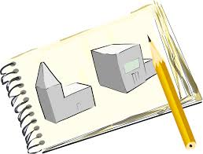 |  | - Everyone Must have a sketchbook  - Sketchbooks are for thinking, planning, and making.  - Sketchbooks are for warm-ups, class work, and project planning.  - You can buy or make your sketchbook. If you choose to buy a sketchbook it must be in the art room by_________________.  - Sketchbooks can be bought at most stores that sell art supplies ($6.00). It will most likely last for all of MS.
Art Rm. Rules:

Respectful
Responsible
Ready

Rewards: Eagle feathers, small tokens
Consequences: warning, Level 1, referral
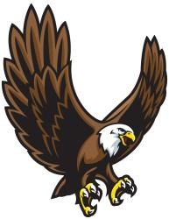 | In the art room  This looks like…  This sounds like…
RESPECTFUL! | - Keeping our voices low.  - Using kind words.  - Following directions.
RESPONSIBLE! | - Having all of your materials every day.  - Putting your things in the right spot.  - Cleaning up your mess.
READY! | - Pay attention and participate.  - Be on time for class.

Follow the 3 R’s
Respectful Responsible Ready

Respectful: Check bad attitudes at the door. Do your best to stay upbeat, cheerful, and pleasant. We all have challenges.
Keep your voices low and to your table.
Follow directions the first time they are given.

Responsible: Come prepared and work to the best of your ability each day. Bring a pencil, sketchbook (art journal), and any assigned materials to each class.
Take care of our tools, technology, and materials.
Get your materials ready quickly and put them back in the right spots.
Clean up after yourself.

Ready: Be on time for class, turn in all assignments on time, and make efficient use of our class time.
Pay attention and participate in class.

